Ideation Phase
PS-1
PS-2
Define the Problem Statements
31 January 2025

Date | 30 September 2026
Team ID | SWTID-2026-7613
Project Name | Auto Ticket Classification using Flow Designer
Maximum Marks | 2 Marks

Customer Problem Statement Template:
Create a problem statement to understand your customer's point of view. The Customer Problem Statement template helps you focus on what matters to create experiences people will love.
A well-articulated customer problem statement allows you and your team to find the ideal solution for the challenges your customers face. Throughout the process, you’ll also be able to empathize with your customers, which helps you better understand how they perceive your product or service.
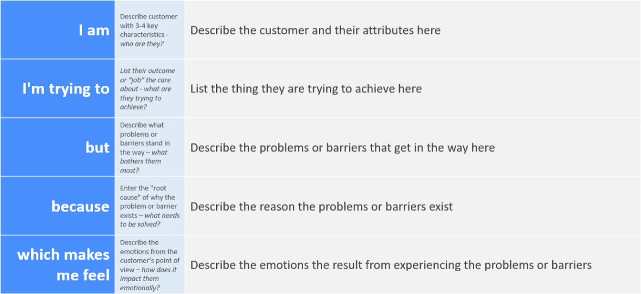
Unsure whether my request was received and frustrated by delays.
There is no automatic classification when a ticket is created, so manual review is time-consuming and inefficient.
IT staff review each request and assign the Category and Subcategory manually.
Get my IT issue reported and routed quickly to the right support team.
A student or teacher at the school who raises IT support tickets (Wi-Fi, projector, password and slow-computer issues).

Reference: https://miro.com/templates/customer-problem-statement/

Example:
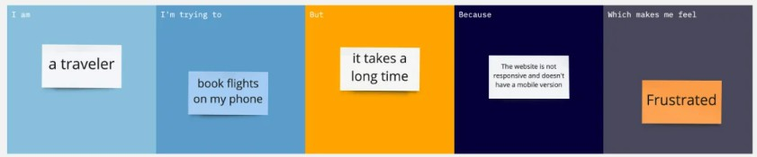

Problem  Statement (PS) | I am  (Customer) | I’m trying to | But | Because | Which makes me feel
PS-1 | A student or teacher who raises IT support tickets | Get my IT issue (Wi-Fi, projector, password, slow computer) reported and routed quickly | IT staff review each request and assign the category manually | Tickets are not classified automatically when they are created | Unsure whether the request was received and frustrated by delays
PS-2 | An IT helpdesk agent who handles incoming incident requests | Classify and route tickets efficiently with minimal manual effort | Reviewing every ticket and setting Category and Subcategory by hand is time-consuming | There is no automation to identify the issue type from the Short Description | Overloaded by repetitive manual work

